44. All real numbers are also complex. 0 is considered real and complex. Complex numbers must be atleast one.
45. a.b.
47.

48.
49.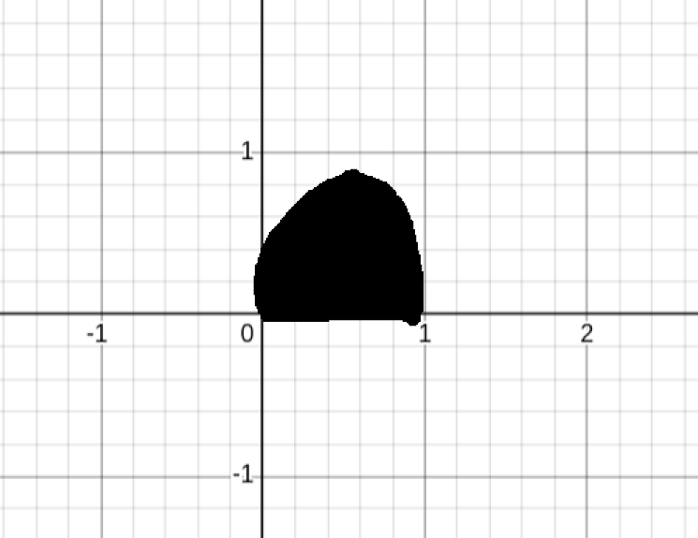
51.
54.
Lemma 1: Scaling a polynomial by a constant factor does not change the roots.

Lemma 2: For any set of complex numbers a polynomial exists that has those numbers a roots.

Lemma 3: A polynomial is uniquely defined by it’s roots and a scalar.

The roots ofare determined byforso the polynomial exists in and has rootsforso the roots also exist in.

All polynomials can be written in the form

